### 2.2.2 Corporate Office Use Cases

#### The Developer has the following set of use cases:

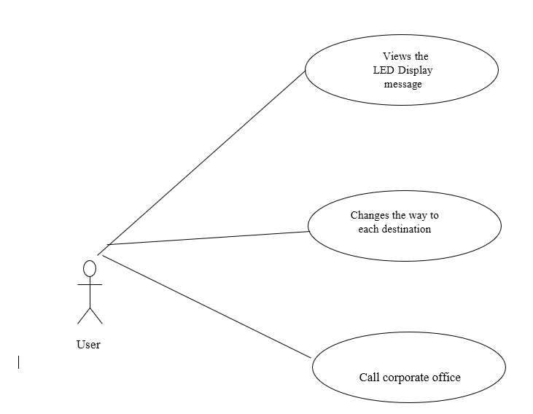

Use case : Views the LED Display message

**Diagram:**

User

Views the LED Display message

**Brief Description**

The User can View the message displayed on the LED Display screen.

**Initial Step-By-Step Description**

1. When any person is travelling on the road, he can know the condition of the Drainage located there with the help of LED display.
2. In case if any work is going on or any problem is there, he can view it through LED screen and change his route to reach the destination.

Use case: Changes the way to each destination

**Diagram:**

User

Changes the way to each destination

**Brief Description**

If drainage is not properly maintained then he/she thinks of the best way to reach destination.

**Initial Step-By-Step Description**

1. While passing user needs to check the LCD display to know whether drainage is overflowed or not.
2. If drainage is not properly maintained then he/she thinks of the best way to reach destination.

Use case: Call corporate office

**Diagram:**

User

Call corporate office

**Brief Description**

The user can call to the nearby corporate office with the help of Phone number displayed on LED display.

**Initial Step-By-Step Description**.

1. If the user identifies that there is no proper maintaince of the Drainage system from a longer period of time he can take action.
2. He can call to the corporate office whose number is displayed on the LED screen and inform them regarding the problem.